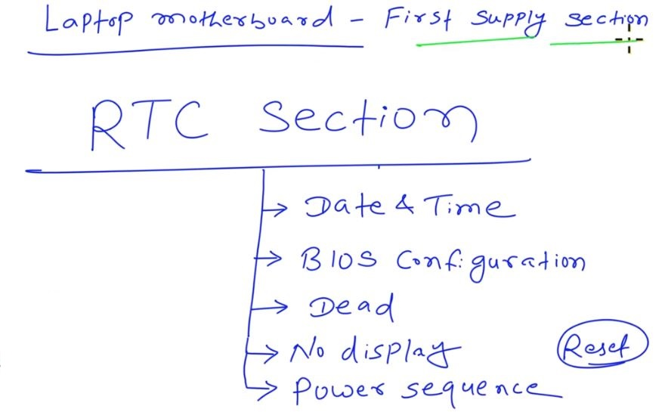
Issue in RTC Section
- Date & time
- Bios configuration – custom setting issue
- Dead
- No Display
- Power Sequence – SLP – Follow nhi hoga – SLP_S5_S4_S3_S0#
- RTC Reset

Process
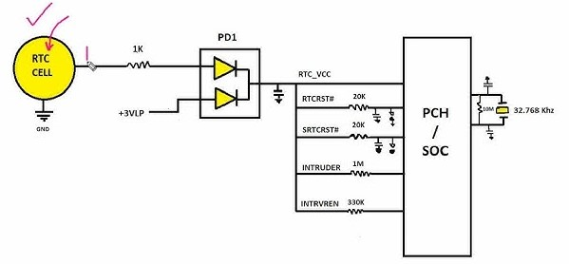
Adapter lga hai to step down circuit working me hai, to 3.3v ldo milega 3 legs diode par…
Diode ke bad below supply milega

- RTC_VCC
- RTCRST#(high ~3v)
- SRTCRST(suspend RTC reset)# (high ~3v)
- INTRUDER
- INTRVREN

All above go to PCH/SOC to activate/alive RTC Domain…
RTC Domain has sub domains

- RTC Clock circuit for date & time…
- CMOS Ram for Bios/UEFI Setting..
- RTC Oscillator circuit -> 32.768 khz ke crystal ke sath milkar clock banata hai. Use SUSCLK bolte hai. SUSCLK - EC/IO, Lan PMIC ke jata hai
- Power Button Wake Logic -> laptop off condition me PCH Power Button Event, LID Switch, & Lan waku dectect ki tyari me rehta hai…
- Power State Retaintion Logic-> Last Power State, AC Loss Recovery, Wake-up configuration, sleep state info..
- RTC Alarm wake logic -> wake-up time par RTC domain, system wake request generate krna hai.
- RTC Well Resistor/ circuit ->power management info.

Note:
Agar Adapter ya Battery laga hai to Setp Down Circuit activate hota hai... To LDO banata hai aur kai board par to 3.3V ALW supply bhi ban jata hai, Power Button Press karne se pehle ban raha hai
TO
ALW 3.3v bhi PCH Ko milta hai…to PCH check krta hai ki jo RTC_VCC Supply aur 3.3v ALW bhi ok hai ya nhi, agar dono ok hai to PCH Out Krta hai ek Signal
PM_RSMRST(resume_reset)# (adapter/batter & 3.3v ALW must)
NO PM_RSMRST# (if battery/adapter not connected)

Agar PM_RSMRST# generate ho rah hai to
1- RTC
2- 3.3 ALW supply OK hai….
PM_RSMRST# -> PCH tab generate krta hai jab RTC Well Logic and Suspend Well (ALW supply ) ready ho jata hai aur IO ke pass bejta hai..
RTC Check List
